Manual Test Plan

1. Run game.py, it will create a pygame window with a randomized new game. Once the game starts, the timer will start counting down.

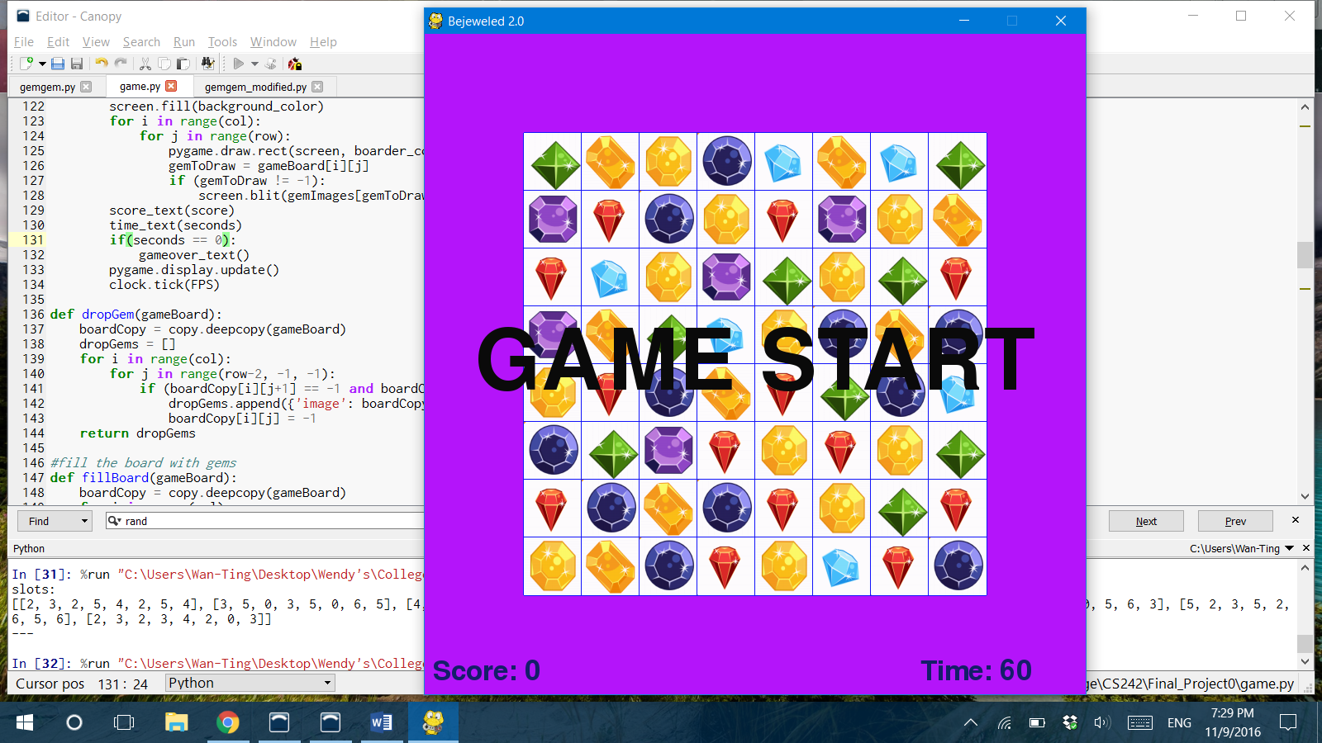

1. 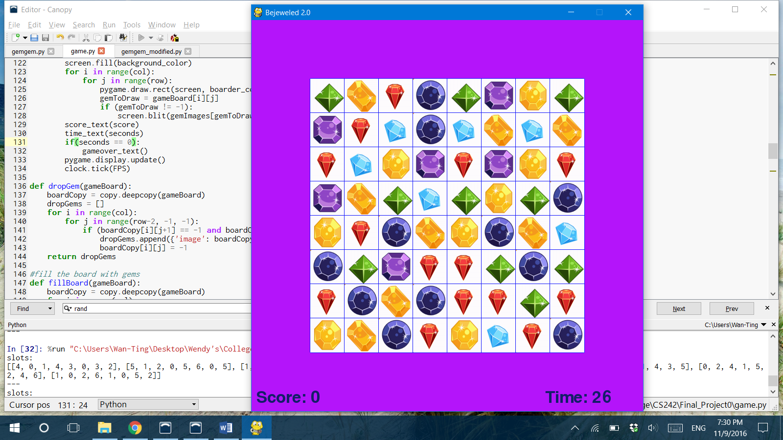Click any two gems to swap to create a link of three or more identical gems, the link will then disappear.

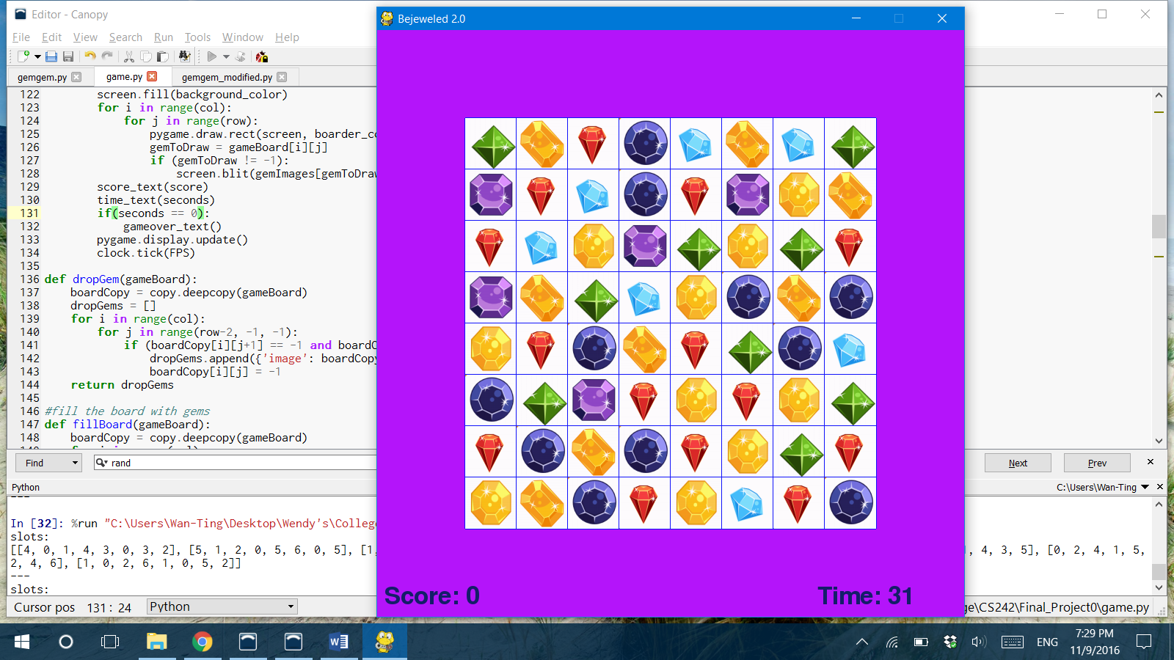

1. Press ‘p’ to pause the game, timer will stop.

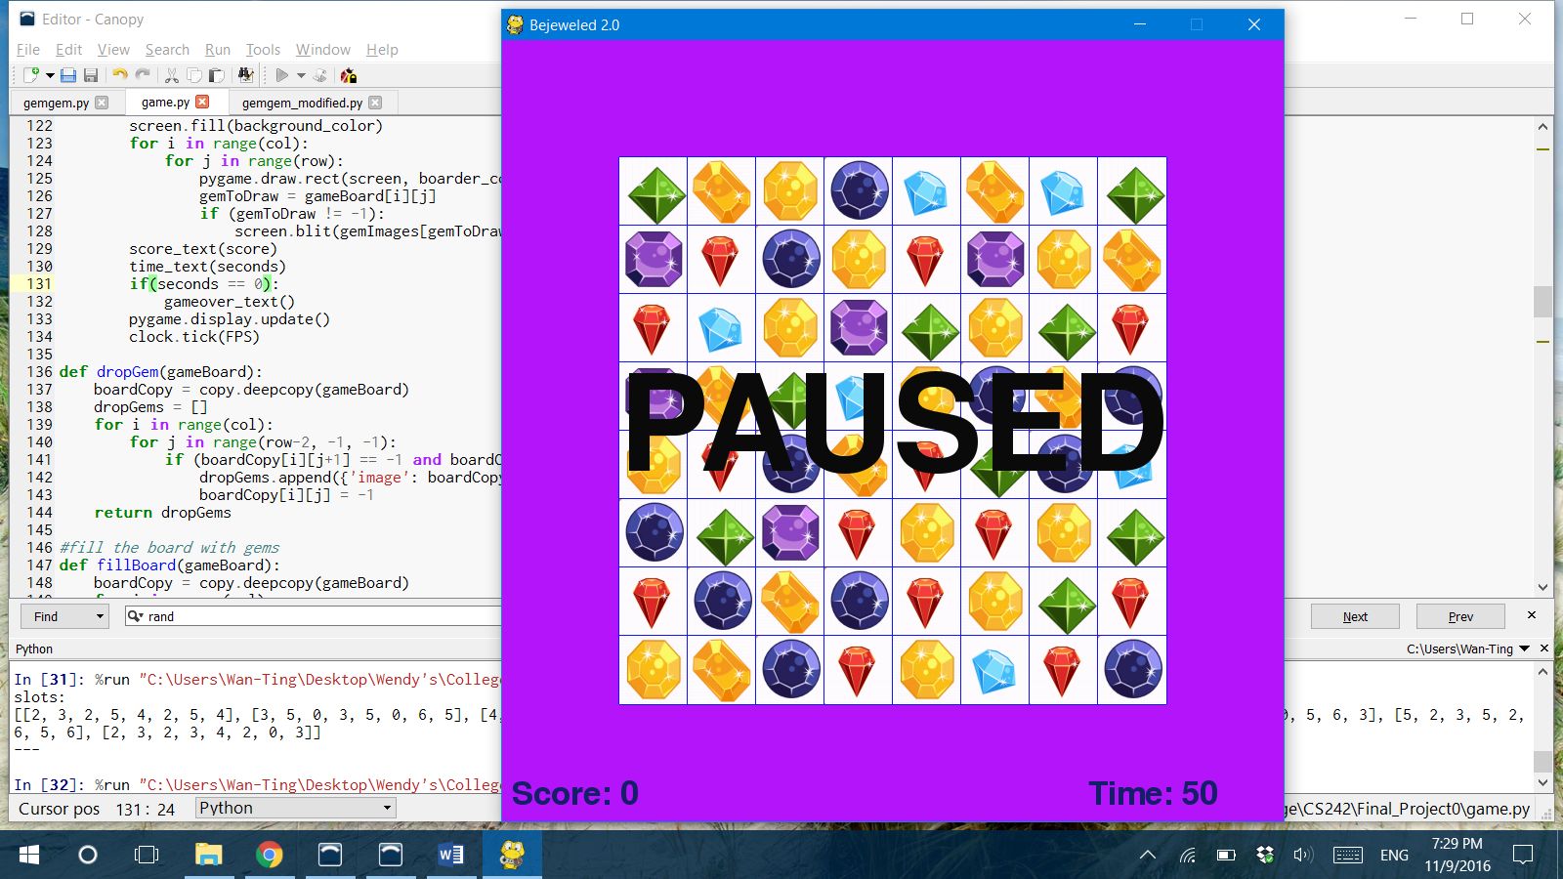

1. Press ‘s’ to resume.
2. Press ‘r’ to start a new game.
3. Press ‘esc’ to exit the game.
4. Game over when timer hits 0

